Voice ranges for:
Trial by Jury
Roles in this summary table are listed in highest to lowest order.
White notes required, black notes optional. Pitches doubled by chorus are ignored
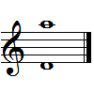  Plaintiff  (Angelina)  (Soprano) | 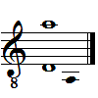  Defendant  (Edwin)  (Tenor) | 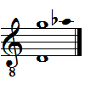  Counsel for  the Plaintiff  (Baritone)
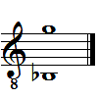  The Learned  Judge  (Comic Baritone) | 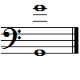  Usher  (Bass-Baritone) | 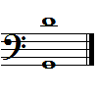  Foreman of  the Jury  (Bass)

HMS Pinafore
Roles are listed in highest to lowest order.
Pitches doubled by chorus are ignored.
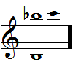  Josephine  (Soprano) | 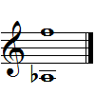  Cousin Hebe  (Mezzo-Soprano) | 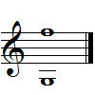  Little Buttercup  (Contralto)
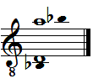  Ralph Rackstraw  (Tenor) | 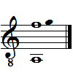  Captain Corcoran  (Lyric Baritone) | 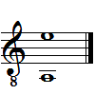  Sir Joseph Porter  (Comic Baritone)
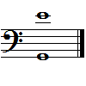  Dick Deadeye  (Bass-Baritone) | 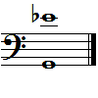  Boatswain's Mate  (Baritone) | 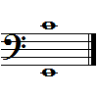  Carpenter's Mate  (Bass)

